**Pen & Paper (A3) Solutions**

**Jesse Sieunarine –** [**jessesi@kth.se**](mailto:jessesi@kth.se)

S1:

S2:

S3:

S4:

S5:

S6:

S7:

S8:

S9:

S10:

S11:

S12:

S13:

2. 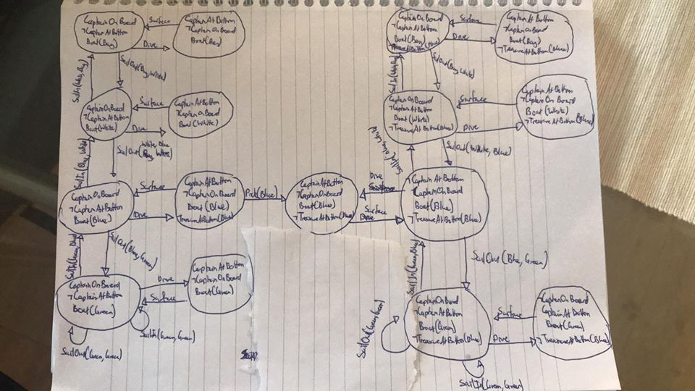
3. 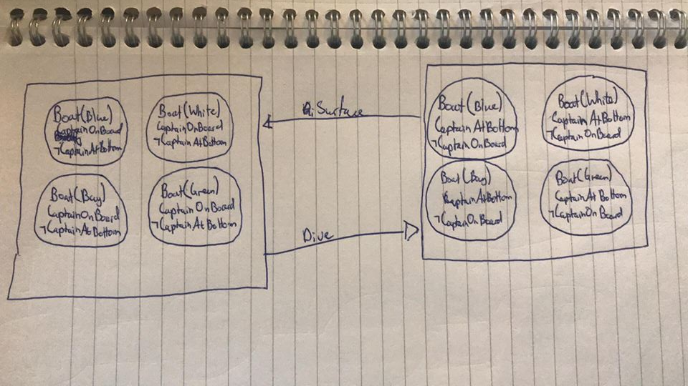

There are infinite plans that lead to the satisfaction of the goal as you can infinitely sail in green waters forever. Even without being able to sail in green waters forever you can still sail back and forth between different waters, hence there are still infinite plans. The most optimal plan would be as follow:

SailOut(Bay, White) 🡪 SailOut(White, Blue) 🡪 Dive() 🡪 Pick(Blue) 🡪 Surface() 🡪 SailIn(Blue, White) 🡪 SailIn(White, Bay)

Therefore the number of actions in the most optimal plan is 7



Fluents that are always true: Next(Bay, White), Next(White, Blue), Next(Blue, Green)

Fluents that are always false: Next(Bay, Blue), Next(White, Green), Next(Bay, Green)

There are 4 actual physical states in the initial belief state. There are no plans that achieve the goal as you can only dive/surface as the constants needed for the predicates for SailOut and SailIn are unknown. (i.e. you don’t know what location you are in).